**Arizona State University  
IFT458**

M7A3

**Student**

Chih-Chieh Chang

**Professor**

Dinesh Sthapit

November 12, 2022

* Github Link
* Home

* Signup a new User

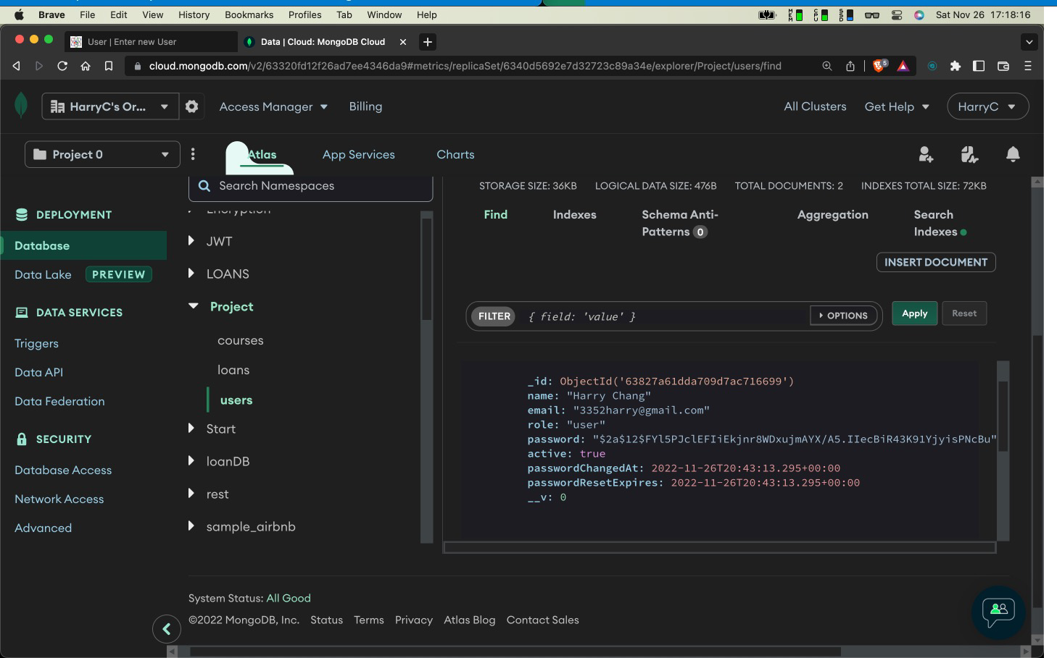

* LogIn the newly created User

* The Users List of Users

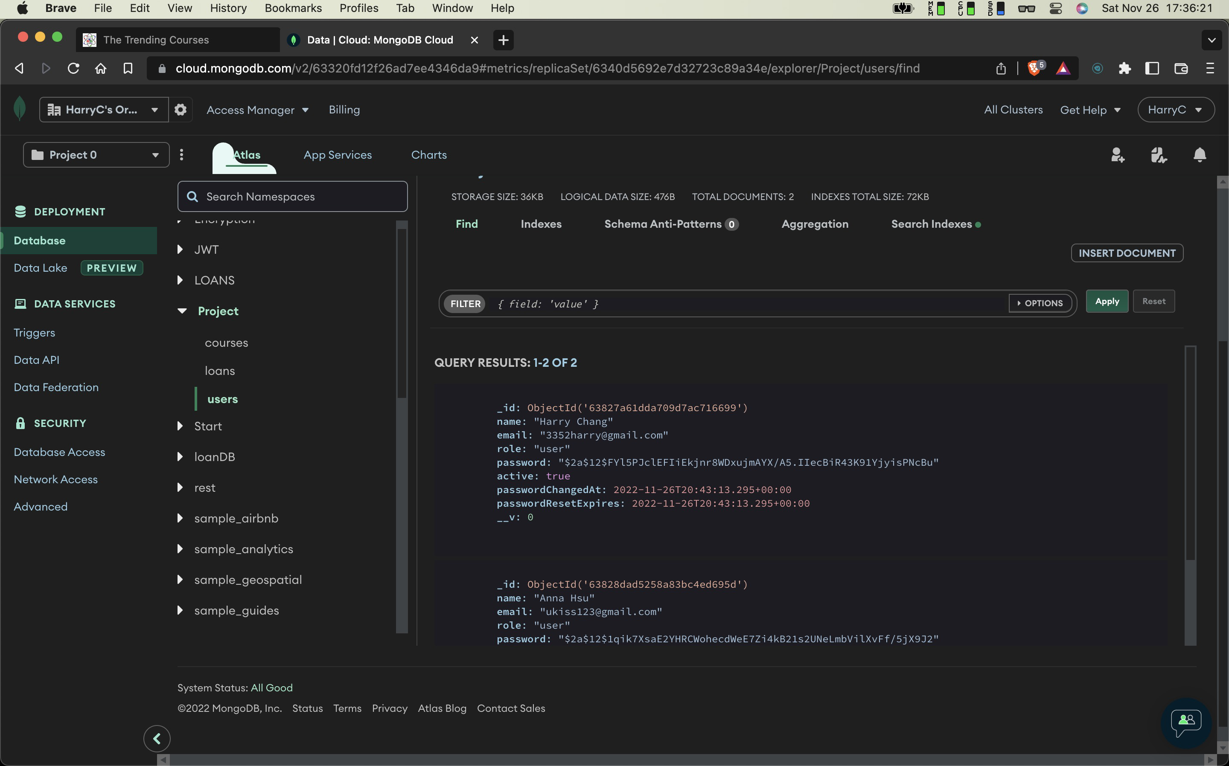

* The Loans

* The Listing of Loans

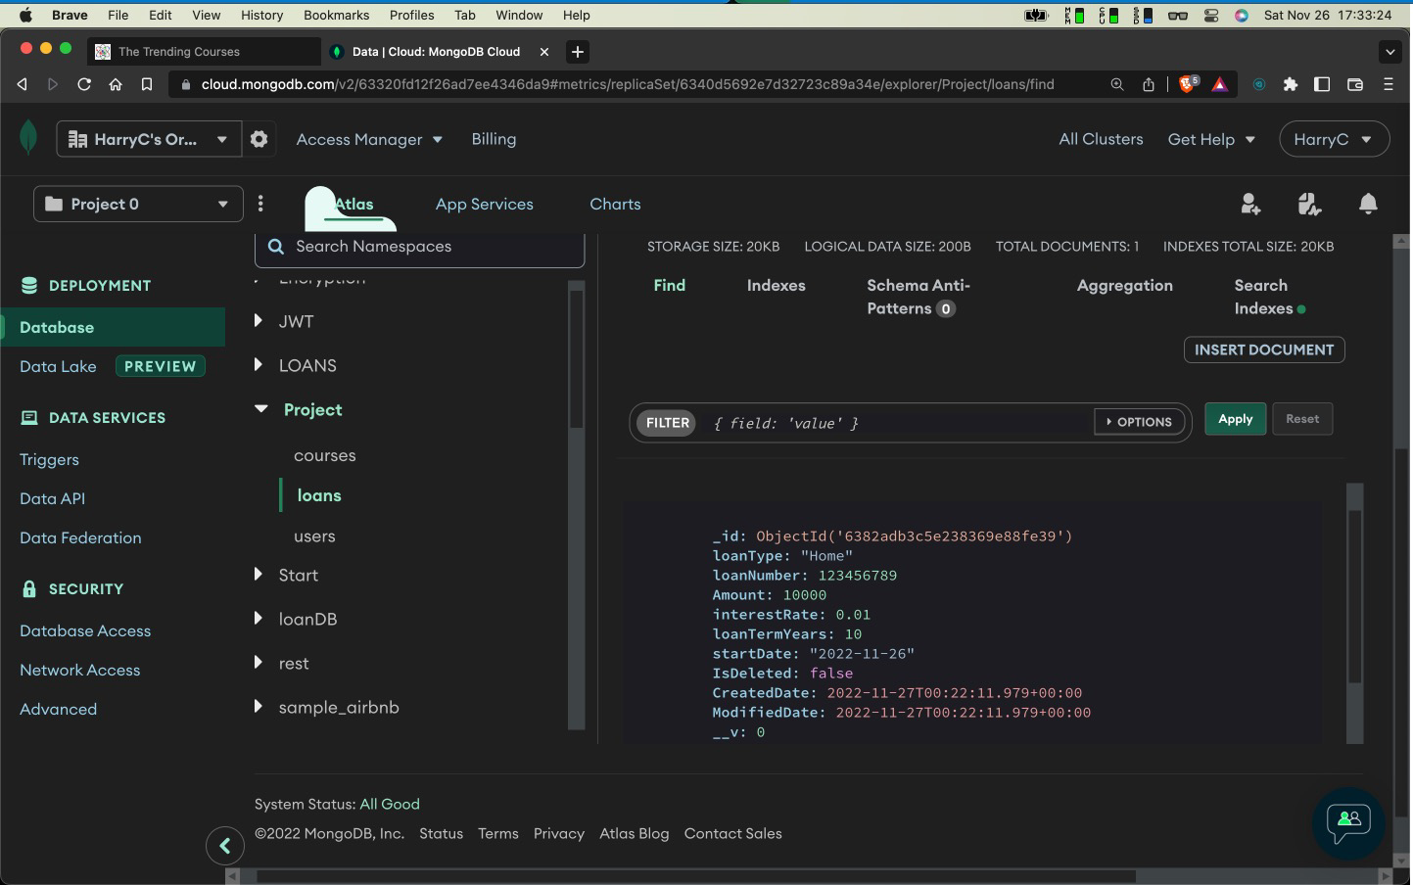

* My loan list

